Css questions

- What is CSS?

- Advantages of CSS.

CSS plays an important role, by using CSS you simply got to specify a repeated style for an element once & use it multiple times because CSS will automatically apply the required styles.
The main advantage of CSS is that style is applied consistently across a variety of sites. One instruction can control several areas which are advantageous.
Web designers need to use a few lines of programming for every page improving site speed.
Cascading sheet not only simplifies website development but also simplifies maintenance as a change of one line of code affects the whole website and maintenance time.
It is less complex therefore the effort is significantly reduced.
It helps to form spontaneous and consistent changes.
CSS changes are device friendly. With people employing a batch of various range of smart devices to access websites over the web, there’s a requirement for responsive web design.
It has the power for re-positioning. It helps us to determine the changes within the position of web elements that are there on the page.
These bandwidth savings are substantial figures of insignificant tags that are indistinct from a mess of pages.
Easy for the user to customize the online page
It reduces the file transfer size.
- Disadvantages

  - CSS, CSS 1 up to CSS3, result in creating confusion among web browsers.
  - With CSS, what works with one browser might not always work with another. The web developers need to test for compatibility, running the program across multiple browsers.
  - There exists a scarcity of security.
  - After making the changes we need to confirm the compatibility if they appear. A similar change affects all the browsers.
  - The programing language world is complicated for non-developers and beginners. Different levels of CSS i.e. CSS, CSS 2, CSS 3 are often quite confusing.
  - Browser compatibility (some style sheets are supported and some are not).
  - CSS works differently on different browsers. IE and Opera support CSS as different logic.
  - There might be cross-browser issues while using CSS.
  - There are multiple levels that create confusion for non-developers and beginners.

- Version
  - CSS3
  - HTML 5
- 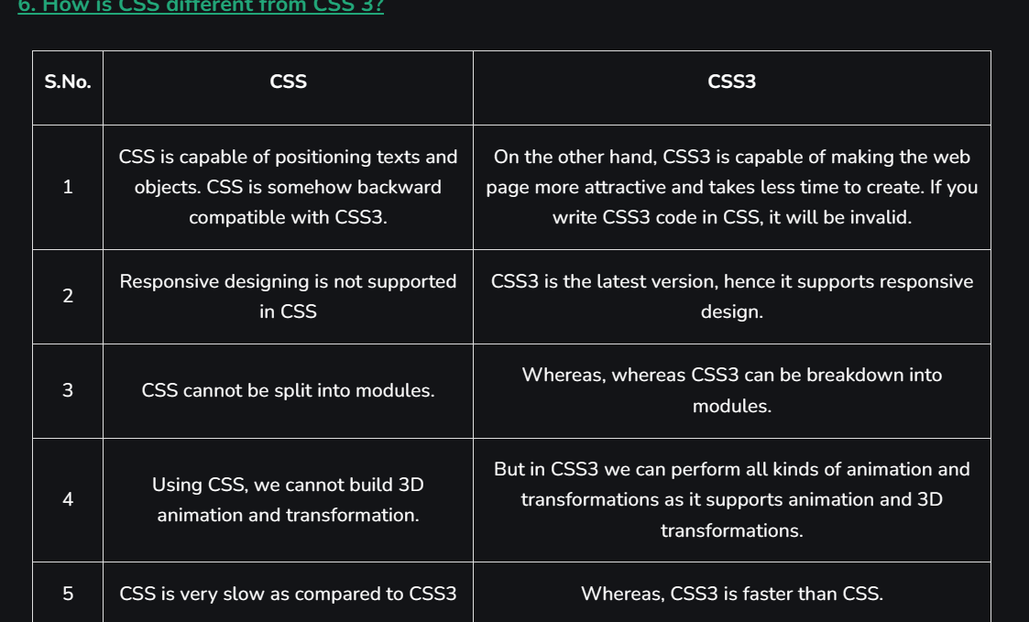
- Frameworks;
  - Tailwind
  - Bootstrap
  - Materialize
  - Sematic UI
- What is the Box model in CSS? Which CSS properties are a part of it?
Content: Actual Content of the box where the text or image is placed.
Padding: Area surrounding the content (Space between the border and content).
Border: Area surrounding the padding.
Margin: Area surrounding the border.

- CSS selector sucha s id and class , * , element type such as <h1>usse to locat where ot style
#container .box {
float: left;
padding-bottom: 15px;
}

<div id="container">
<div class="box"></div>

<div class="box-2"></div>-
</div>

<div class=”box”></div>
- Comment /* content */

- RGBA contains A (Alpha) which specifies the transparency of elements. The value of alpha lies between 0.0 to 1.0 where 0.0. represents fully transparent and 1.0 represents not transparent.
Syntax:
h1 {
color:rgba(R, G, B, A);
}
- HSL
- Background properties in ?
background-color: This property specifies the background color of an element.
background-image: This property specifies an image to use as the background of an element. By default, the image is repeated so it covers the entire element.
background-repeat: By default, the background image property repeats the image both horizontally and vertically.
background-attachment: This property is used to fix the background ground image. The image will not scroll with the page.
background-position: This property is used to set the image to a particular position.
- Different CSS Border properties.
- Border-style - mandatory (solid,dashed,dotted)
- Border-width - must be in pixels, etc.
- Border-color - can be set using color name, etc.

15. Padding format -
padding 10px 12px 14px 10px ( clockwise direction).
16. . Difference bw margin and padding
- Margin is space outside of the element while padding is space inside.
- Margin can be -ve or float but padding can’t.
17. Difference bw border and outline.
Outline cant be customized its just a boundary across the element while border can be customized.
Outline cant be circular

- 17. How can we format text in css.
  - Text-color
  - Text-alignment
  - Text-decoration
  - Text-transformation
  - Text-indentation
  - Letter spacing
  - Line height
  - Text-direction
  - Text-shadow
  - Word spacing

- Css links state
  - <a>
    - Hover
    - Active
    - /visited
- Hide
  - Display none
- After none can flex image or element have to use block
- Visibility : hidden “space stays same ”
  - Display: none “no space ”
- Display property:
  - Fixed
  - Static
  - Relative (positioned with respect to the center og parent)
  - Absolute (means positioned with respect to parent )
  - Sticky

- Visiblity hidden:
  - visible
  - hidden
  - scroll
  - auto
- display:inline-block do?
- 2d transformation
  - Rotate
  - Spin
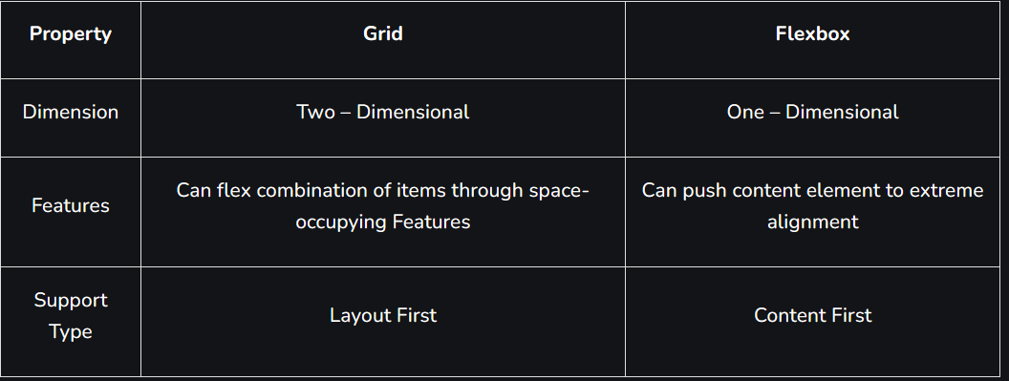

Animate

<style>
div {
width: 200px;
height: 200px;
margin: 200px;
border-radius: 100px;
background-color: red;
animation: circle 8s infinite;
}

@keyframes circle {
0% {
background-color: red;
}

25% {
background-color: yellow;
}

50% {
background-color: blue;
}

100% {
background-color: green;
}
}
</style>

